

|  |
| --- |
| Apparel and Footwear |
| Label Printing |
| Argentis |



**www.argentisconsulting.com**

Label - Apparel

The path where the information files the label is: Administration 🡪 Setup 🡪 Apparel and Footwear 🡪 Setup 🡪 General Settings 🡪 Path.

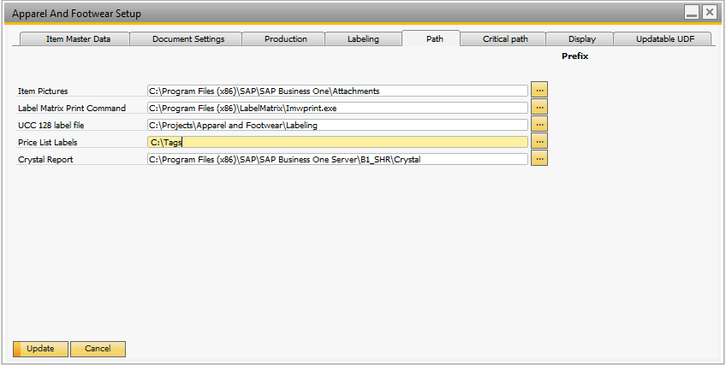

**Path**

* Label Matrix Print Command: In this field you can enter the path to the folder with the print command of the executable file of the software Matrix Label. (Only per software Label Matrix)
* UCC 128 Label File: In this field you can enter the path to the folder with the file created for the labels UCC 128.
* Price List Labels: In this field you can enter the path to the folder with the list of prices to print the labels UCC 128.

**UPC Label Tags**

Administration 🡪 Setup 🡪 Apparel and Footwear 🡪 Inventory 🡪 UPC Label Type

When selected the "UPC Label Tags", you can upload the files that correspond to the UPC Label. To do this, complete the "Code", "Name" and "File" and select Update.

Being the Default option: Label Matrix.

1. Label Matrix (Default): Label Matrix integration, a middleware of the company teklynx

<http://www.teklynx.com/>

2. Crystal Report. Label printing using crystal report.

3. *Zebra Thermal Label. Printing from SAP in printers that receive commands ZPL y EPS. This integration was perform with Neodynamic ([www.neodynamic.com](http://www.neodynamic.com)). Licenses are needed.

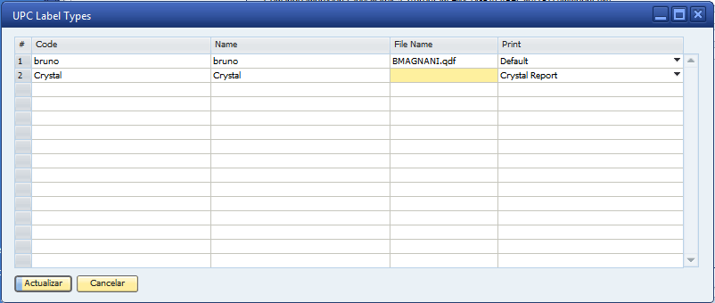

**Print Labels with Prices**

Go to: Apparel and Footwear 🡪 Inventory 🡪 UPC Label Printing 🡪 Labels

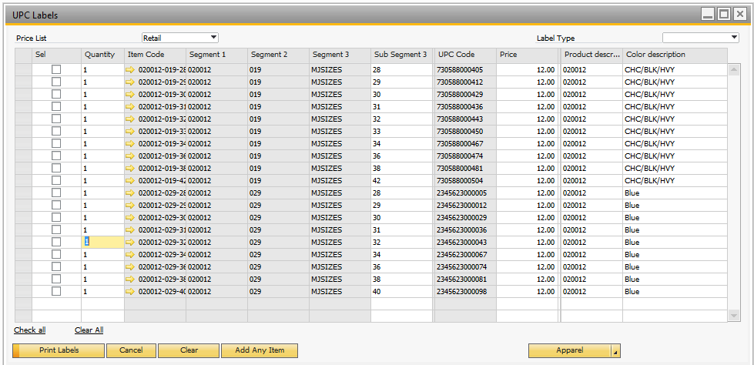

Select the items and the Price List, and then select the option “Print Labels”. After that select the printer configuted. Argentis reccomends Label Matrix.

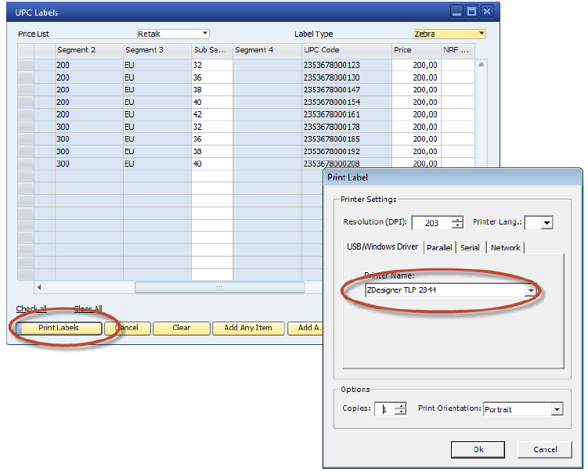



**Argentis Consulting** is dedicated to the development, distribution and support of recognized certified solutions for SAP Business One, as an SSP (Software Solution Provider) with a Gold Partner status.

.

**www.argentisconsulting.com**

|  |  |
| --- | --- |
| **USA**  9744 NW 45th Lane  Doral, FL 33178  info@argentisconsulting.com | **ARGENTINA**  Ávila y Zarate 2048  Cerro de la Rosas, Córdoba,  CP 5009  Córdoba - Argentina  info@argentisconsulting.com |
| **CARIBEAN**  City View Plaza – Suite 301  48 Road 165  Guaynabo, PR. 00968  Puerto Rico  caribe@argentisconsulting.com | **SPAIN**  C/ Juan Bravo N° 3 A 28006  Phone: (+34) 91 123 7263  Madrid - Spain  info@argentisconsulting.com |

**Contact Information**

**CONTATO**